**Moviles**

Mario Linares

Noviembre 25, 2023

APP REPORT: Signal

Juan Felipe Patiño 201922857

**Gabriela Paez 201822911**

**Juan Martin Santos 202013610**

Table of Contents

Table of Contents 1

1. Core Functionalities 2

2. Repositories 6

3. Business Question 8

4. Architecture 11

5. User Interface and User Experience 15

a. Color Pallets 15

b. Fonts 15

c. Iconography 16

d. Views 16

6. Quality Attributes 19

7. Libraries 20

8. Technical Audit Report: Connectivity Strategies and Performance Strategies 22

a. Executive Summary 22

b. Technical Component 23

i. Eventual Connectivity 23

ii. Caching Strategies 28

iii. Memory Management Strategies 32

iv. Threading/Concurrency Strategies 34

9. Technical Audit Report: Profiling and Analyzing Micro-Optimization Strategies 38

a. Executive Summary 38

b. Technical Component 38

i. Performance Scenarios 38

ii. Micro-Optimizations 44

10. References 51

1. Sprint 1 App Report



Throughout this report, Signal, an open-source application which can be found in the following link on the [app store](https://apps.apple.com/us/app/signal-private-messenger/id874139669) and its source code in the following GitHub link <https://github.com/signalapp>, will be analyzed. Signal is an instant messaging mobile application; however, it also has a desktop version for computers, which only works if the person has the app downloaded on their phone with an active account. Before talking about the key features of this app, it's important to understand its history. Signal, the flagship app of the Signal Foundation, a non-profit organization dedicated to open-source privacy technology, doesn't generate its own income, but rather receives donations from users and benefactors. In 2017, Brian Acton, who is now the CEO of the company, invested $50 million in Signal to support its operation (Curry, 2023). We like this revenue model, that does not revolve around ads or selling users information (as far as we know), but instead receives donations to create revenue. The issues of security and privacy are large concerns currently, and there are a significant number of people who will donate to keep this app functioning and so that they can come up with new updates that will respect their privacy.

# Core Functionalities

This app is described as an alternative to more popular applications such as WhatsApp or Telegram (Fernandez, 2021). But how does Signal differ from these other instant messaging applications? What would be some important features for a person that would make them choose Signal over Whatsapp? Signal possesses all the basic features of a messaging app, like allowing one-on-one and group conversations, where sharing content (be it links, voice notes, images, emojis, etc) is enabled. Furthermore, signal has another feature which is not present in most messaging apps which is called in-app payment. This consists of linking *MobileCoin*, a cryptocurrency, onto your signal account. If this is done through signal the sender, receiver, amount transferred, and message are all unknown to the app. If a user activates this option, then they will be able to receive and send this coin through their Signal account. Currently, a user cannot cancel or undo a payment after they have confirmed it, even if they turn of their phone. For this feature to work, it is necessary to have a Signal pin (like a passcode). On another note, note to self, is a feature that other messaging apps, such a Whatsapp, didn’t have until very recently, and Signal has had for longer. This consists of a chat where users can message themselves, with the intention to be like a notepad. The complete list of basic features is shown below. This table can be found in the official Signal page:

* “[Calling options - Switch camera, microphone, or view](https://support.signal.org/hc/en-us/articles/5369785769370-Calling-options-Switch-camera-microphone-or-view)
* Screen Sharing with Signal Desktop Calls
* Schedule a Message on Signal Android
* Stories

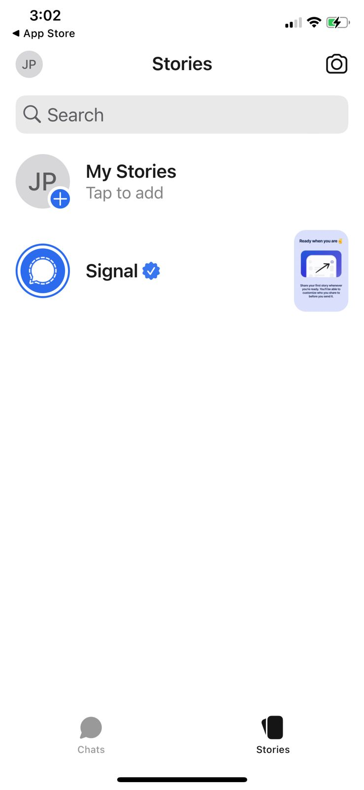

**Figure 1**. Stories menu in the Signal mobile app on IOS

* Chat Colors, Wallpaper, and Themes
* Set and manage disappearing messages
* Data Usage Options (Wi-Fi & Cellular)
* Note to Self
* Archiving or unarchiving chats
* In-app Payments
* Proxy Support
* Show in Suggestions
* Incognito Keyboard
* Change Number
* View Message Details
* Group Link or QR-code
* Manage a group
* Delete for everyone
* @ Mentions in Group Chats
* Storage Management
* Font Size Options
* Language Options
* Mark as Unread
* Forward
* Pin or Unpin Chats
* Broadcast Media
* In-App Notification Options
* Message Reactions
* View-once Media
* Stickers
* Signal Desktop Keyboard Shortcuts
* Navigate to Settings

**Figure 2.** Setting´s menu in the Signal mobile app on IOS

* Typing Indicators
* Signal Android Insights
* Link Previews
* Screen Security
* Unlinking devices
* How do I know if my message was delivered or read?
* Linked Devices
* Delete messages, alerts, or chats
* Leave a group
* Dual Sim
* Invite friends to join Signal
* Block numbers or groups
* Read Receipts
* Signal PIN
* Backup and Restore Messages
* Screen Lock
* View and save media or files (Signal Support)”

Nonetheless, Signal is mostly known for its enhanced security features. These features include being able to block the app with a password, your face or a fingerprint (depending on the model of the phone), using a private number, and controlling the disappearance of messages and content. Furthermore, it also offers tools to safeguard the communication between users and their data (Smith & McCall, 2021) Currently, Signal uses end-to-end encryption, even when sending stickers, so that only the people in the chat can see the content of the messages. Furthermore, Signal collects basically no data from its users (only the phone number), so users can be relaxed that their data won't be sold through Signal (Silva & Kraus, 2023).

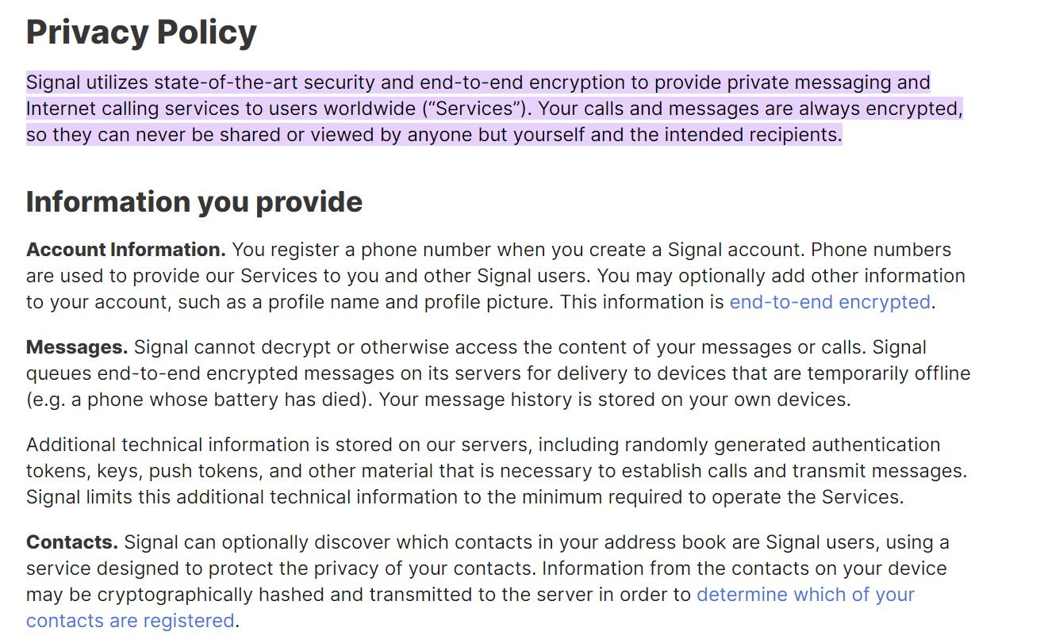

**Figure 3.** Signal´s privacy policy (*Terms of service & privacy policy)*

Even though Signal was launched on July 29th of 2014, most of the downloads of the app did not happen until 2021. By 2019, the app had 10 million cumulative downloads, but in 2021, after Snowden endorsed it, this number went up to 125 million, with most downloads happening in the first quarter of 2021. In the last year and a half (from the start of 2022 to the second quarter of 2023) there have been approximately 37,200 downloads (Statista).

We consider Signal interesting due to two key factors. One has to do with publicity, and one has to do with the code. Regarding publicity, we think that with privacy a one of the key features and the importance of this topic in the last few years, we’d expect Signal to be doing better, and at least nearing WhatsApp levels of use, but in downloads and active users it is significantly behind. We think that this has to do with a lack of publicity and general knowledge of this app outside of the United States, but we would like to analyze the trends a bit more to understand why it is not as popular as other messaging apps. The second reason why it interests us has two do with two features in the coding. The first being that it is open source, so that people who have development experience and wish to can help, for example they can tackle open issues in the GitHub repositories to make it better (How can I contribute to Signal?). This method of collaborative work is great, and lets people see the code behind the app that they are using. The second aspect is the importance on guaranteeing privacy to the user and not selling their data, which should be a key aspect of Signal, especially when so many companies are selling their users data nowadays.

# Repositories

Given our motivation to analyze Signal, its history and general features and popularity, it is now important to understand the repository of the app (since it is open-source). For starters under the Signal account there are five repositories, one for android, one for desktop, one for iOS, one for servers and one for a library they own as we can see in **Figure 4**. In this case we will be focusing on the iOS signal repo as this sub-group will be working on iOS specifically, of which we can see a picture in **Figure 5**. As it is the iOS repository we expected and found the vast majority of the work done with Swift as 90.2% of the whole repo. As far as the rest of the work, most of it is done in the other language used for app development in iOS, Objective-C, with 8.5% of the repo, with both of these adding up to 98.7% the rest are nearly 0% with the exception of Python at 1.1%, as seen in **Figure 6**.

**Figure 4.** *Repositories of Signal [August 15th, 2023]*

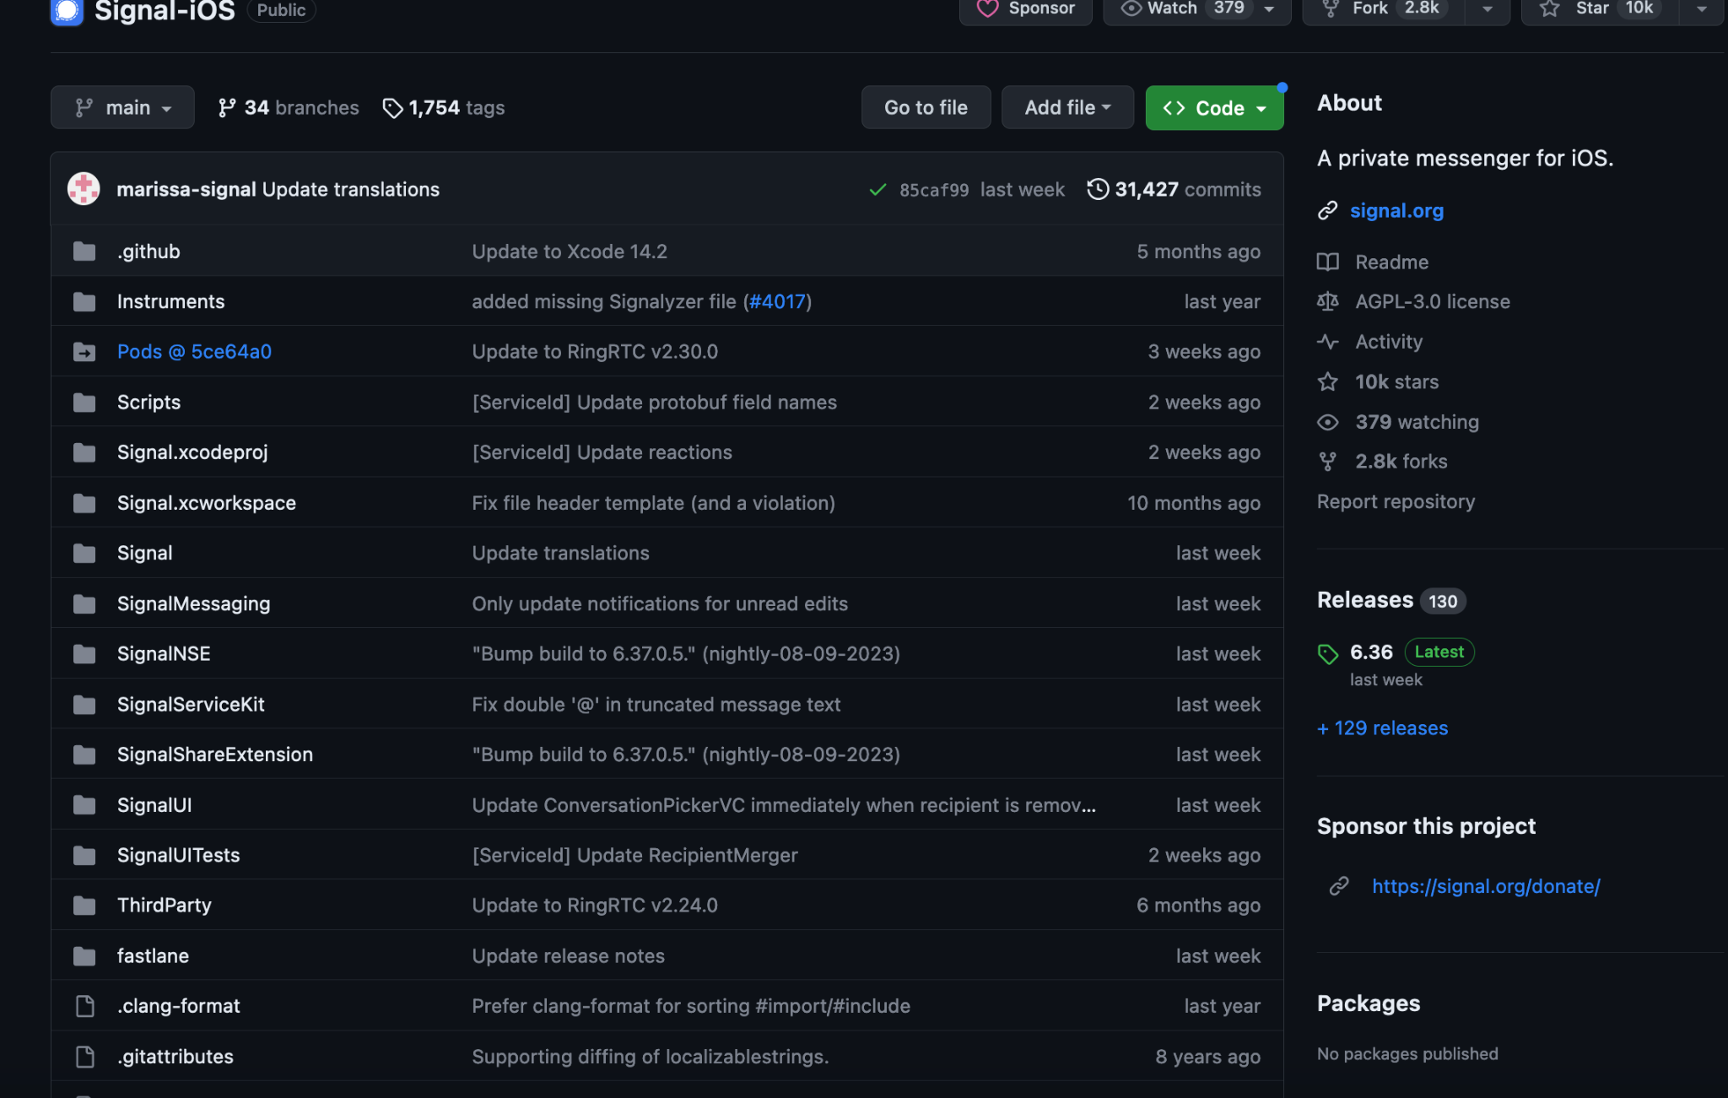

**Figure 5.** *SignaliOS Repository [August 15th, 2023]*

**Figure 6.** *Code share of repository [August 15th, 2023]*